NASA’s Affirmative Procurement Program

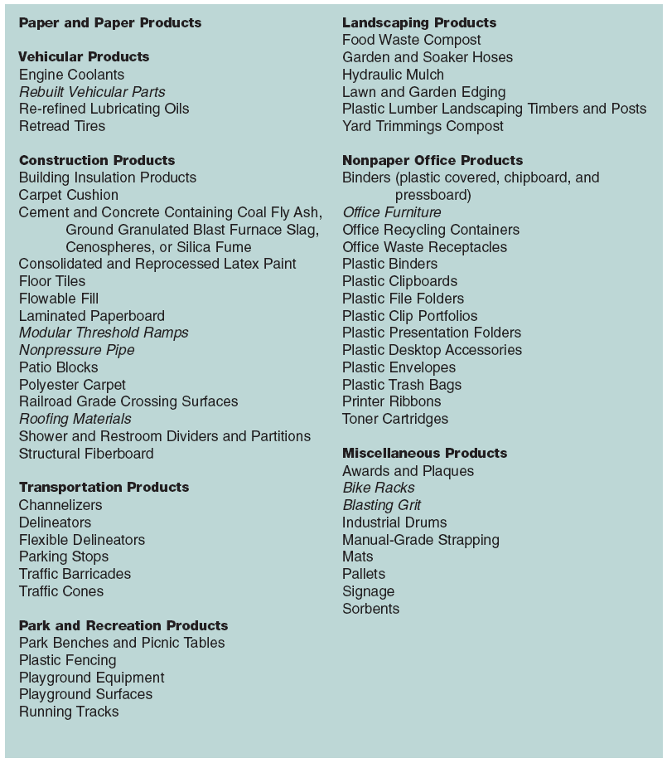
PURPOSE: NASA’s Affirmative Procurement goal is to increase purchases of products containing recovered materials and environmentally preferable products and services.

BACKGROUND The Resource Conservation and Recovery Act (RCRA) and Executive Order 13101, “Greening the Government Through Waste Prevention, Recycling, and Federal Acquisition”, Federal Acquisition Regulations (FAR 23.4), and NASA’s Procedures and Guidelines (NPG) 8830.1 requires NASA to have a purchasing program that gives preference to items containing post consumer recycled materials and that are environmentally preferable.

DESCRIPTION: The U.S. EPA has published the Comprehensive Procurement Guidelines (CPG) which specifies recycled content and Environmentally Preferable (EP) standards for a variety of items in eight product categories (see list to right). EP Purchasing is buying “products or services that have a lesser or reduced effect on human health and the environment, when compared with competing products or services that serve the same purpose.” Bio-based products which are made from plant and tree-based products instead of petrochemical products are an example of environmentally preferable products.

REQUIREMENTS FOR ALL PURCHASERS: Individuals purchasing any item listed in the CPG must purchase products with recycled content unless a waiver is approved for one of the following reasons:
* A product does not meet appropriate performance standards.
* Not available within a reasonable amount of time.
* Product is not available competitively from two or more sources.
* The product is only available at an unreasonable price.
Completed waiver forms (copy on back) must be sent to Environmental Management Division, MS 237-14 (reference NPG 8830.1, section 3.21).

COST ANALYSIS: More than just purchase price must be considered when determining the cost of an Affirmative Procurement item. The life-cycle cost should be used, which considers other factors such as maintenance cost and the total life of the product. To calculate the life cycle costing assessment for a product that deviates from the Affirmative Procurement Program, NASA recommends that each center evaluate the following cost criteria:

+ Associated training and management | + Replacement
+ Handling and transportation | + Treatment or disposal
+ Potential liabilities | + Using the products
+ Record keeping | + Waste minimization efforts

Questions:
Environmental Management Division 4-5660.
http://environmentalmanagement.arc.nasa.gov/
REQUEST FOR WAIVER – Affirmative Procurement
NASA Ames Research Center

To be completed by Request Originator. Send completed forms to Sustainability Coordinator, Mailstop 237-14. Or fax to 4-0680.

Item purchased from: NASA Store (AIB Express)□ Other:
(Name supply source)
Project Name:
(Name project if purchase was required for a specific project, otherwise write “N/A”)

CPG¹ Item(s) Purchased  (e.g. file folders, envelopes, insulation, concrete, motor oil, printer cartridges) | Quantity Purchased | Cost
- EPA’s Comprehensive Procurement Guidelines (CPG). Check the CPG list for recycled content requirements at www.epa.gov/cpg/products.htm.

Waiver Justification

Items meeting the CPG recycled content levels were not purchased because (check all that apply):

Recycled-content product only available at an unreasonable price
Recycled-content product not available within a reasonable time
Use of minimum recycled content standards would result in inadequate competition.
Recycled-content product does not meet quality/performance specifications.

Other explanation (attach any supporting documentation to form).

Request Originator Name (print) Organization Date

Signature of Request Originator

Do not write in box below.

Approval Signature of Environmental Program Manager or Designee Date

